
A 12
Sreenidhi Institute of Science & Technology
(An Autonomous Institution)
Code No: 124CA01
MCA - I – Year I – Semester Examinations, August, 2013 (Supplementary)
MATHEMATICAL FOUNDATIONS OF COMPUTER SCIENCE

Time: 3 Hours Max. Marks : 60

Note : No additional answer sheets will be provided.

Part-A (Objective Type)
Max.Marks:10

Answer all QUESTIONS.
- An onto function is also known as
a. Injective function b. Surjective function
c. Bijective function d.None of the above
2. Transitive and Irreftexive imply
a. Symmetric b. Reflexive c. Irreflexive d. Asymmetric
3. In how many ways can the letters of the word “ LEADER” be arranged ?
a. 75 b. 144 c. 360 d. 720
4. ( P ↑ Q) ↑ ( P ↑ Q ) is logically equivalent to
a. ¬P b. ¬ Q c. P d. ¬ ( P ↑ Q )
5. Which of the following is a valid argument from the Premises
P → ( Q → R ), P ^ Q.
a. R b. P c. Q d. None of these
6. A binary operation * defined on ( R, * ) where X * Y = X^{Y} is ___________.

7. If G is a finite graph then the number of edges denoted by |E ( G)| is called as ____________.
8. A tree is a _____________________.
9. FSM can recognize ___________________.

10. ______________ has multiple transitions on a start state for the same input symbol.
Part – B
Max. Marks: 50
ANSWER ANY FIVE QUESTIONS. EACH QUESTION CARRIES 10 MARKS.

1. a. Draw Hasse Diagram for the Partial ordering { ( A, B ) : A < B} on the power set [ 5 ]
P ( S ) where S = { a, b, c }.
b. Let A = { 1, 2, 3, 4, 5 } and R = { ( a, b) : a, b, A and a ≥ B }. Write the relation matrix of R. [ 5 ]

2. a. Find the number of integral solutions to the equations [ 5 ]
X₁ + X₂ + X₃ + X₄ = 50
Where X₁ ≥ - 4, X₂ ≥7, X₃ ≥ -14 and X₄ ≥ 10.
b. How many ways can 3 integers be selected from the integers 1, 2, 3,…… 30.So that their sum is even. [ 5 ]

  - a. Write an equivalent formula for P∧( Q ↔ R ) which contains neither bi-conditional nor conditional. [ 5 ]
b. Construct the truth table for the following compound propositions. [ 5 ]
i. P → (¬ Q∨R ) ii. ( P↔¬R ) ∧{ ( R → Q ) ∨ ¬Q ]

4. a. Indicate the variables that are free and bound. Also show the scope of the
Quantifiers. [ 5 ]
(i) (x) ( P(X) ∧ R(x)) → (x) P (x) ∧ Q(x)
(ii) (x)(P(x) ∧ (x) Q(x)) ∨ ((x)P(x)} → Q (x)
b. Prove that the following arguments are valid ( or) invalid.
(i) P → R ii) (¬P∨Q) →R
¬Q → P R→(S ∨T)
¬ R ¬S∧¬U
------------ ¬U→¬T
∴Q ------------
∴ P

5. a. Let G be the following graph shown then [ 5 ]
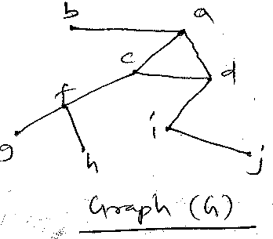
How many connected sub graphs of G have four vertices and include a cycle ? Also draw these sub graphs.
b. Draw the following graphs. [ 5 ]
i. K_{3,3} ii. W₆

6. a. For the graphs shown below, find a spanning free and obtain all the corresponding fundamental circuits and fundamental cut sets. [ 5 ]
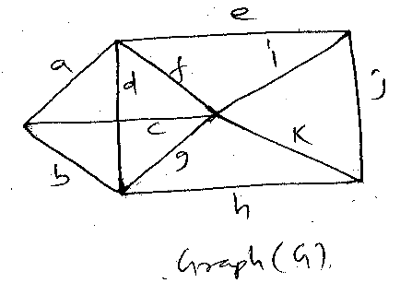
b. Suppose that a connected planar graph has six vertices each of degree 4. Into how many regions is the plane divided by a planar representation of this graph. [ 5 ]

7. a. Design FA to check whether given decimal number is divisible by three. [5]
b. Design a PDA for accepting a language [ 5 ]
{ L = a^{n} b^{n} |n ≥ 1 }

-- 00 -- 00 --

